**Dissolved Organic Matter Experimental Setup**

**Standard Operating Procedure**

Starting an Experiment:

1. Uncap stock solution bottles and open the valves for the water and waste lines

*Figure 1: The waste and water lines in the lab*

Red line is the waste line

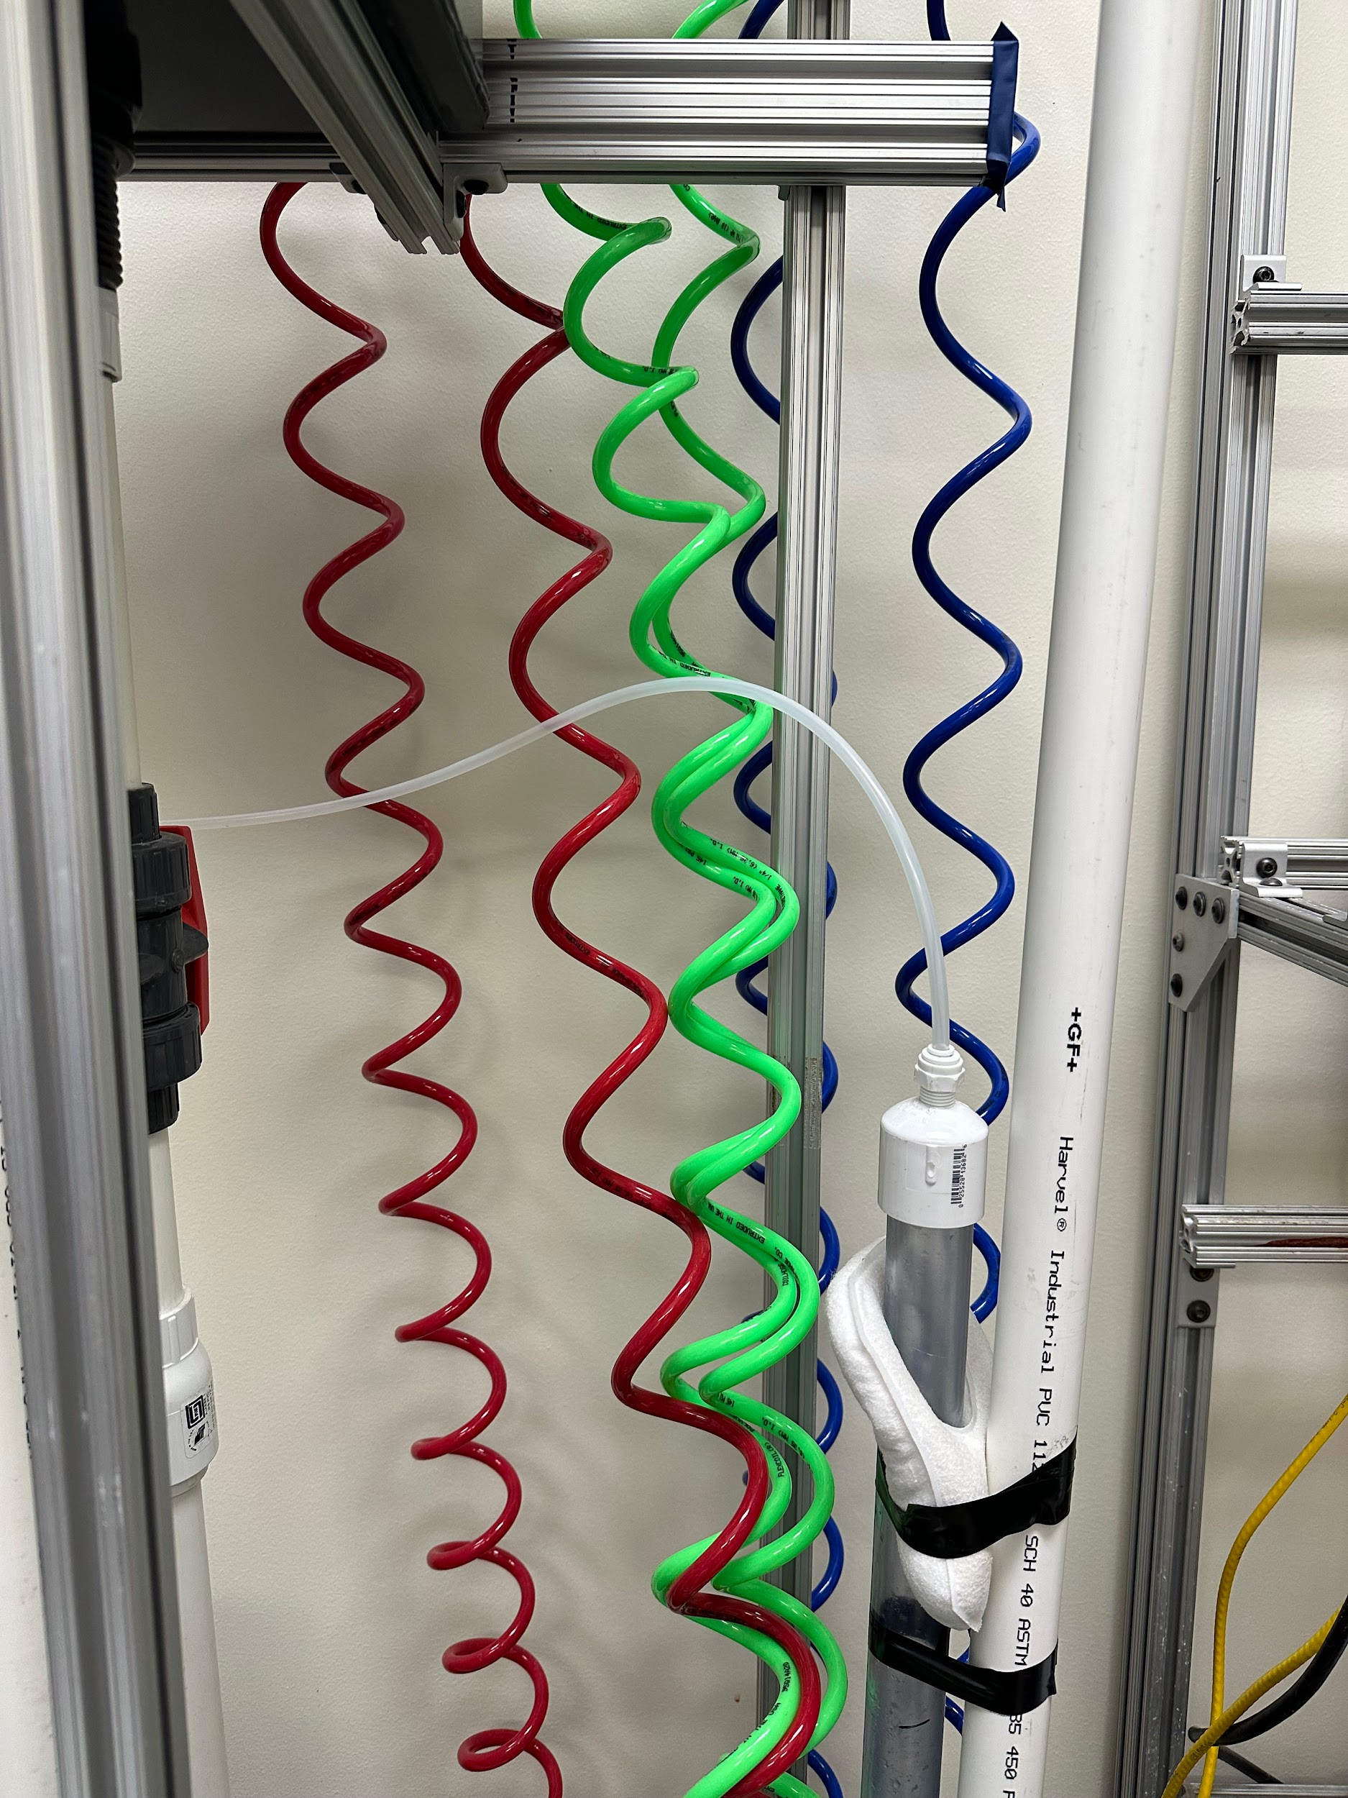

Blue line is the water line

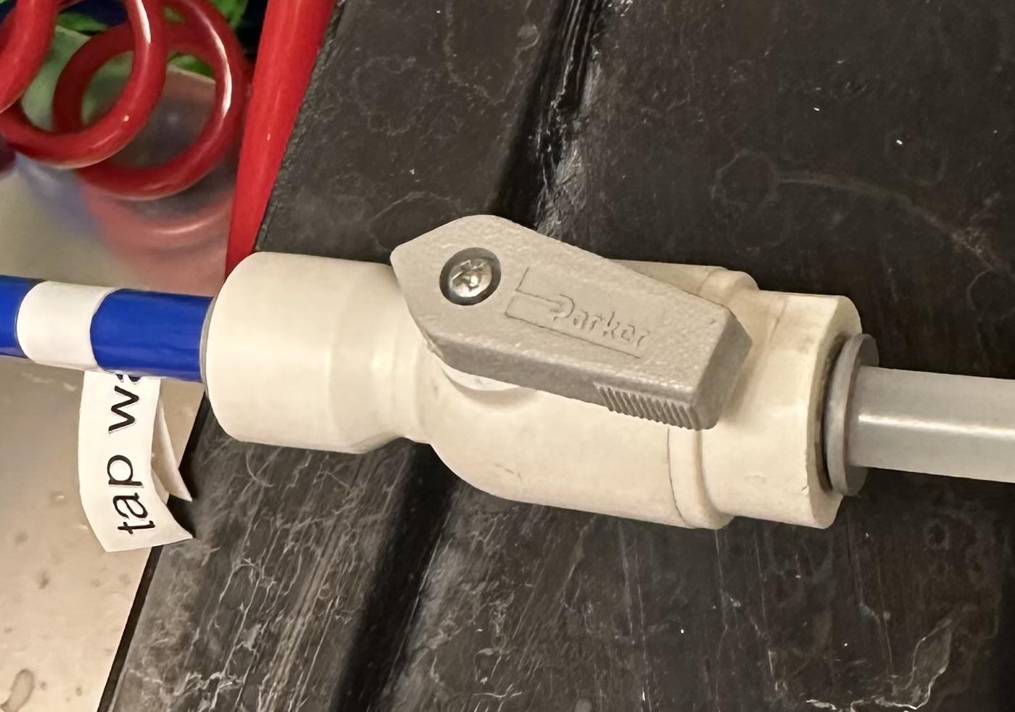

*Figure 2: To switch ON the value, turn the switch so that it is parallel to the pipe.*

* 1. The stock solution bottles are uncapped to ensure that a vacuum does not form and inhibit the flow of solution into the setup.

1. Turn on stir plates (such as the stir bar to keep PAC/clay suspended in solution)
2. Turn on the pumps by reaching to the back of the pumps and turning on the rubber switch



*Figure 3: Switch to turn on Golander pump (boxed in red)*

1. Turn on the turbidimeters by flipping the lever on the black box

*Figure 4: Levers to turn on/off the turbidimeters (boxed in red)*

1. Switch to ‘Run’ on the ProCoDA file
   1. Open ProCoDA using the icon on the taskbar of the computer

* Always open the method file through ProCoDA and never from the file downloaded on the computer. It will cause the PC to open infinite tabs.

*Figure 5: ProCoDA icon on the taskbar (boxed in red)*

* 1. Click on the box below ‘Operator Selected State’ tab and click ‘Run’

*Figure 6: ‘Operator Selected State’ tab and ‘Run’* *Option* *(boxed in red)*

* 1. For more information, see ProCoDA documentation in the AguaClara textbook: https://monroews.github.io/EnvEngLabTextbook/ProCoDA/ProCoDA.html

1. Visually inspect each pump to ensure solutions are flowing appropriately
   1. Ensure no backflow into stock solutions - this can ruin a solution if left for an extended period of time
   2. Ensure water is coming out of blue tube
   3. Ensure waste is flowing into red tube

Terminating an Experiment:

1. Switch to ‘OFF’ on ProCoDA

*Figure 7: ‘Operator Selected State’ tab and ‘Off’ option (boxed in red)*

1. Turn off stir plates, pumps, and turbidimeters
2. Tightly cap the stock solution bottles to prevent any leakages
3. Switch off the valves on the water and effluent pipes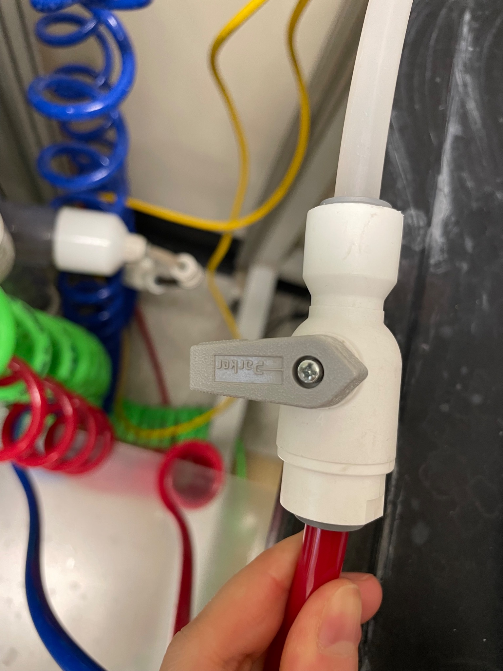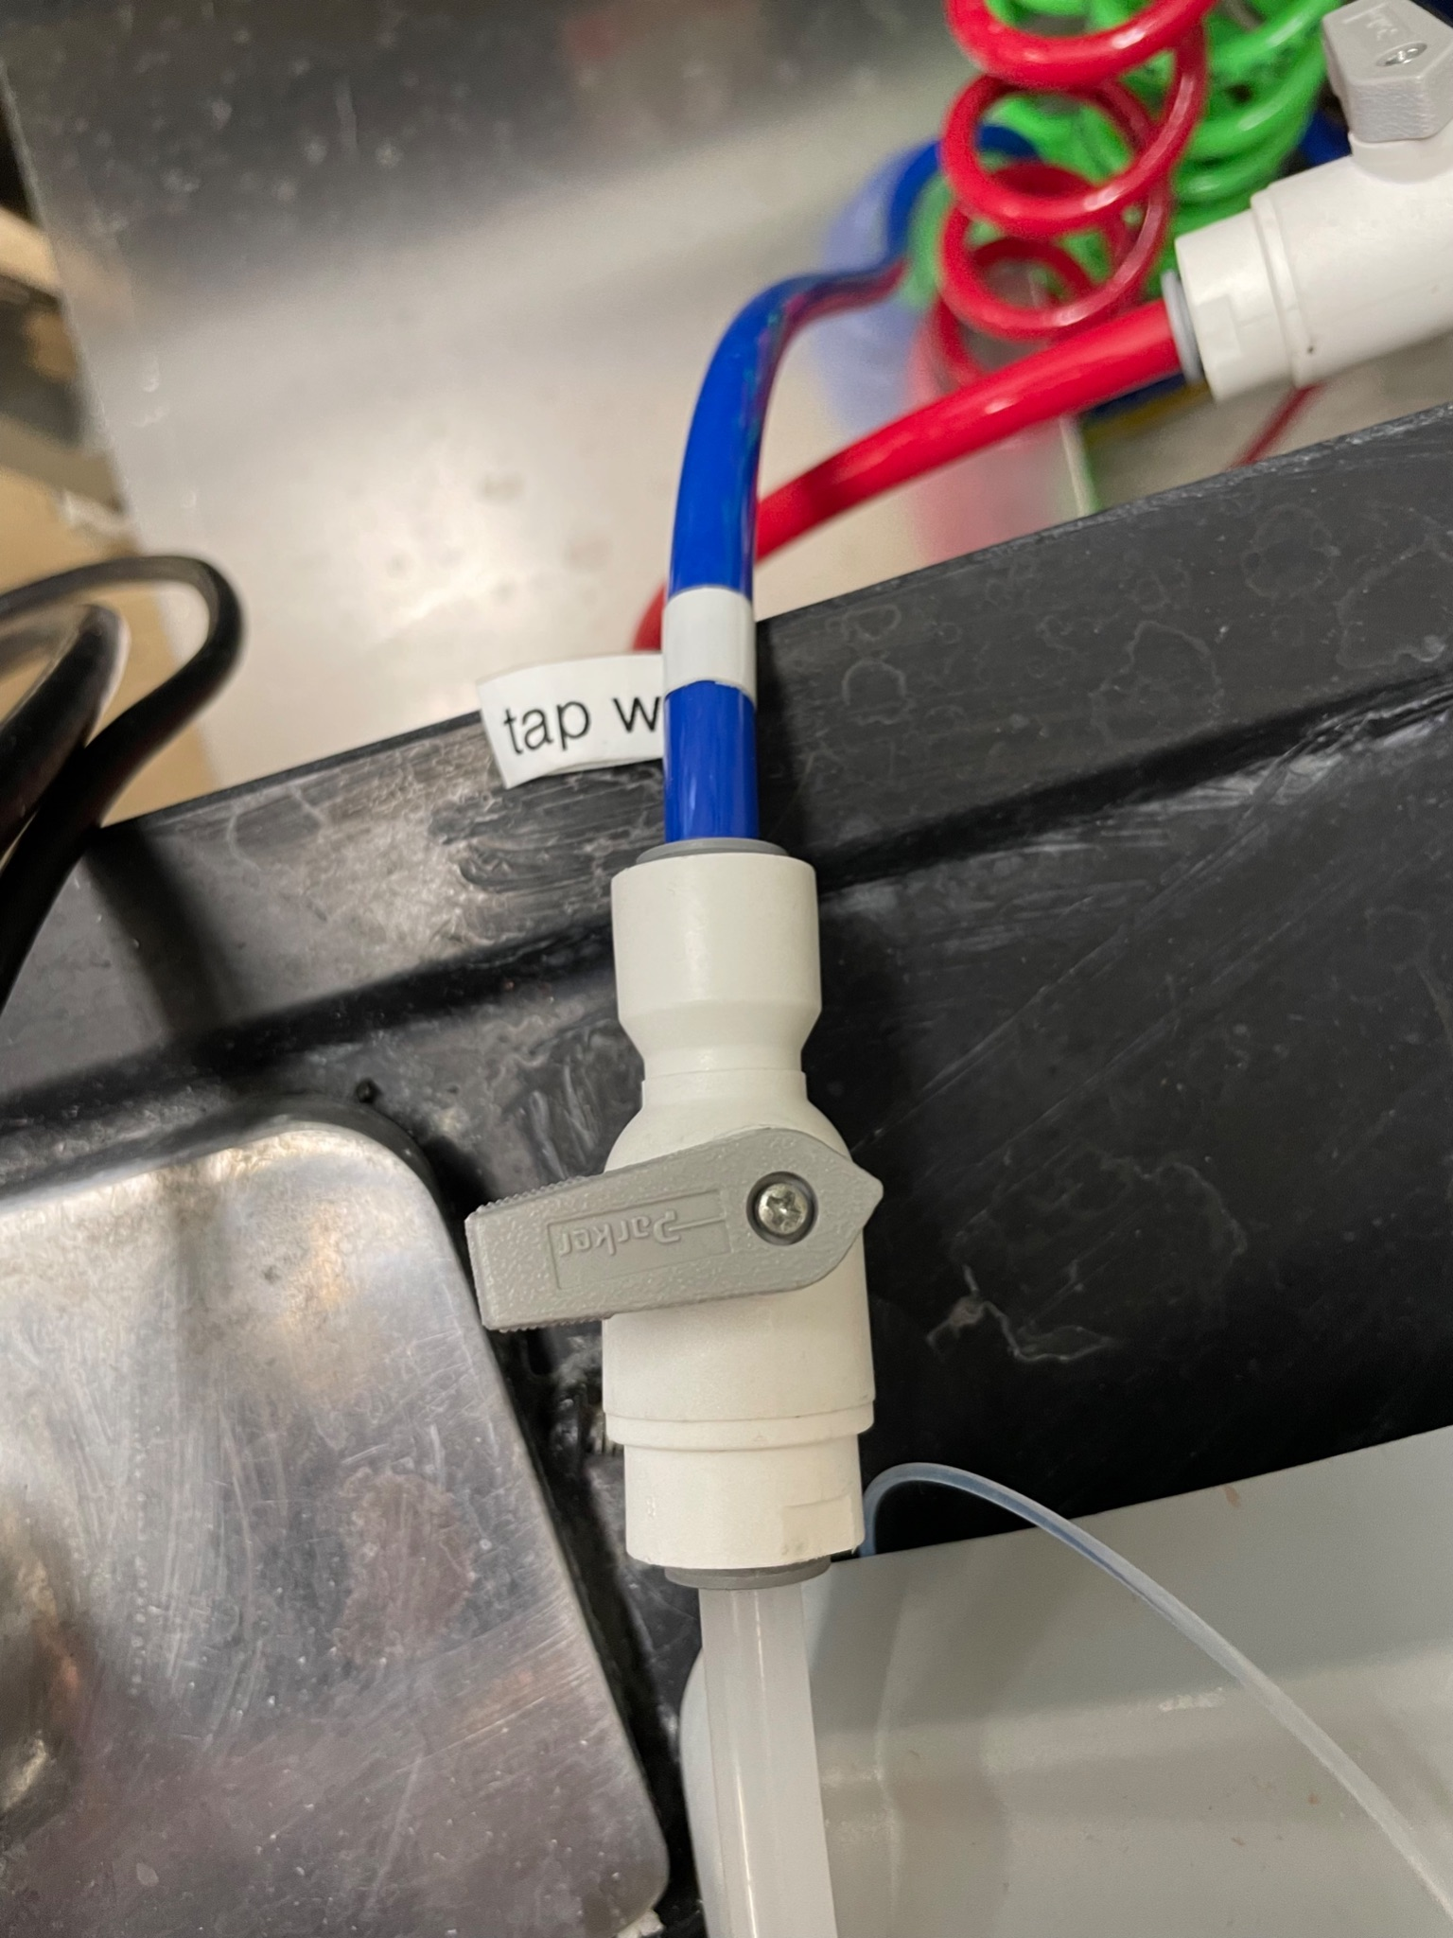

*Figures 8 and 9: The water and effluent valves are in the OFF state (the valve switch is perpendicular to the pipe)*

1. Clean up the lab environment

Important Things to Keep in Mind:

* Label stock solution bottles with either a label maker or a piece of tape and a marker
  + Make sure to identify the solution’s name, concentration, and date when it was made
  + Remove any old labels when a new solution is made
* Follow lab safety guidelines when working with chemicals (e.g., wear gloves and goggles)
* Put materials back in their correct locations when finished using them

Adding Set Points or Changing Parameters on ProCoDA

1. Go to ‘Configuration’ tab and click ‘Edit rules’

*Figure 10: ‘Edit rules’ button in the ‘Configuration’ tab*

1. In the ‘Set Points’ tab
   1. If do not want to mess with the order and fail the ‘control’ set points
      1. Click the last set point on the list
      2. Click ‘Add Set Point After’
      3. Specify the unit, type, and value
   2. If have to insert new set points in between existing set points
      1. Choose the set point to which the new set point should append to
      2. Click ‘Add Set Point After’
      3. Specify the unit, type, and value
      4. Go into every set point of type ‘variable’ to ensure that all ‘Required Set Points’ are correctly selected in the ‘selected set points’ section.

*Figure 11: ‘Set Points’ tab. The blue set points on the right are the required checkpoints for the blue checkpoint on the left. All the buttons to add and delete checkpoints are on the left of the setpoints.*

**\*The order of the ‘Required Set Points’ have to be the same in the ‘Set Points and Variable List’ (e.g. the pump address set points have to come before the setpoints for the on state, pump speed, and flow rates)**

1. Click ‘OK’ when you are done
2. Click on the second icon under ‘Method files’ to save the ProCoDA file

*Figure 12: The save button in the ‘Method files’ tab is boxed in red*

Installing ProCoDA

1. Follow the steps on Monroe’s Github https://github.com/monroews/LabVIEW/wiki/ProCoDA
   1. Make sure the drivers are installed for the serials ports and adaptors
      1. Can check on device manager if the USBs do not have yellow triangle (indicates something is missing)
         1. If you are missing the driver, you can google the driver file online
         2. The driver for the adapter works for the serial port
2. To make sure the pumps are connected to ProCoDA, reset the pump IDs
   1. The serial port should be COM4 

*Figure 13: Modbus port drop down menu and COM4 selection. Click on the neon green button for the window to show up.*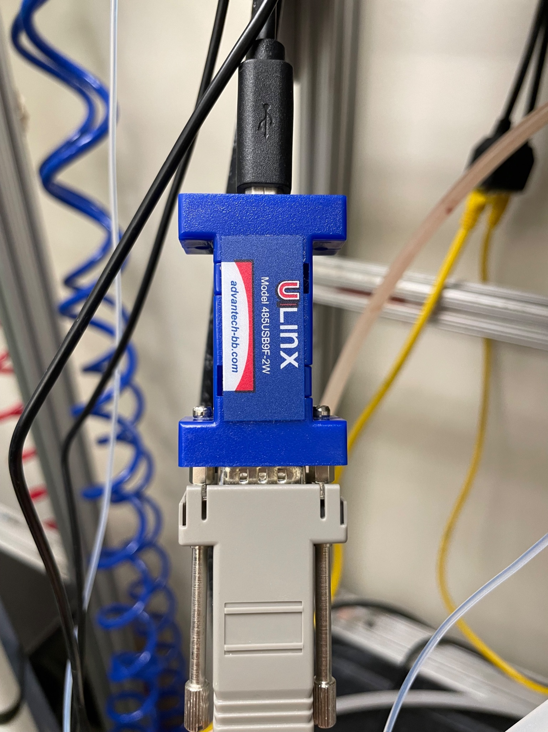

*Figure 14: Modbus port. Top end connected to the PC through the black wire and the bottom end connected to the pumps through the yellow wire.*

* 1. Unplug all the yellow wirings except for the one attached to Modbus port and the one pump you are setting the ID to
  2. Select “Set Modbus ID button”.

*Figure 15: Modbus ID button*

* 1. Set the ID to a larger number that isn’t used to make sure it is connected. Then reset to the number you want as long as it has not been set to another pump already. Turn the pump off and then back on.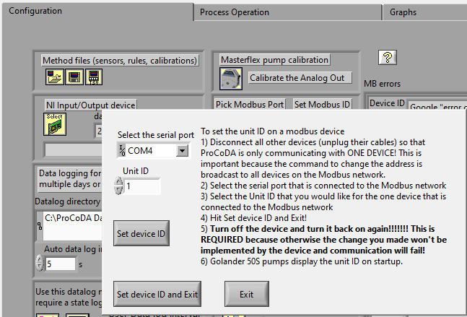

*Figure 16: Pop-up window for ID selection. Make sure the serial port is COM4, click “Set device ID and Exit” once done.*

* 1. Reconnect the wirings for each pump
     1. It should be in follow order (One wire from Modbus adapter to pump 1, one wire from pump 1 to pump 2, one wire from pump 2 to pump 3, one wire from pump 3 to pump 4, one wire from pump 4 to pump 5, one wire from pump 5 to turbidimeter 1, one from turbidimeter 1 to turbidimeter 2, and so forth)

Calibrating Turbidimeters and Connecting to ProCoDA

Calibration Instructions: https://aguaclara.github.io/aguaclara_tutorial/research/turbidimeters.html

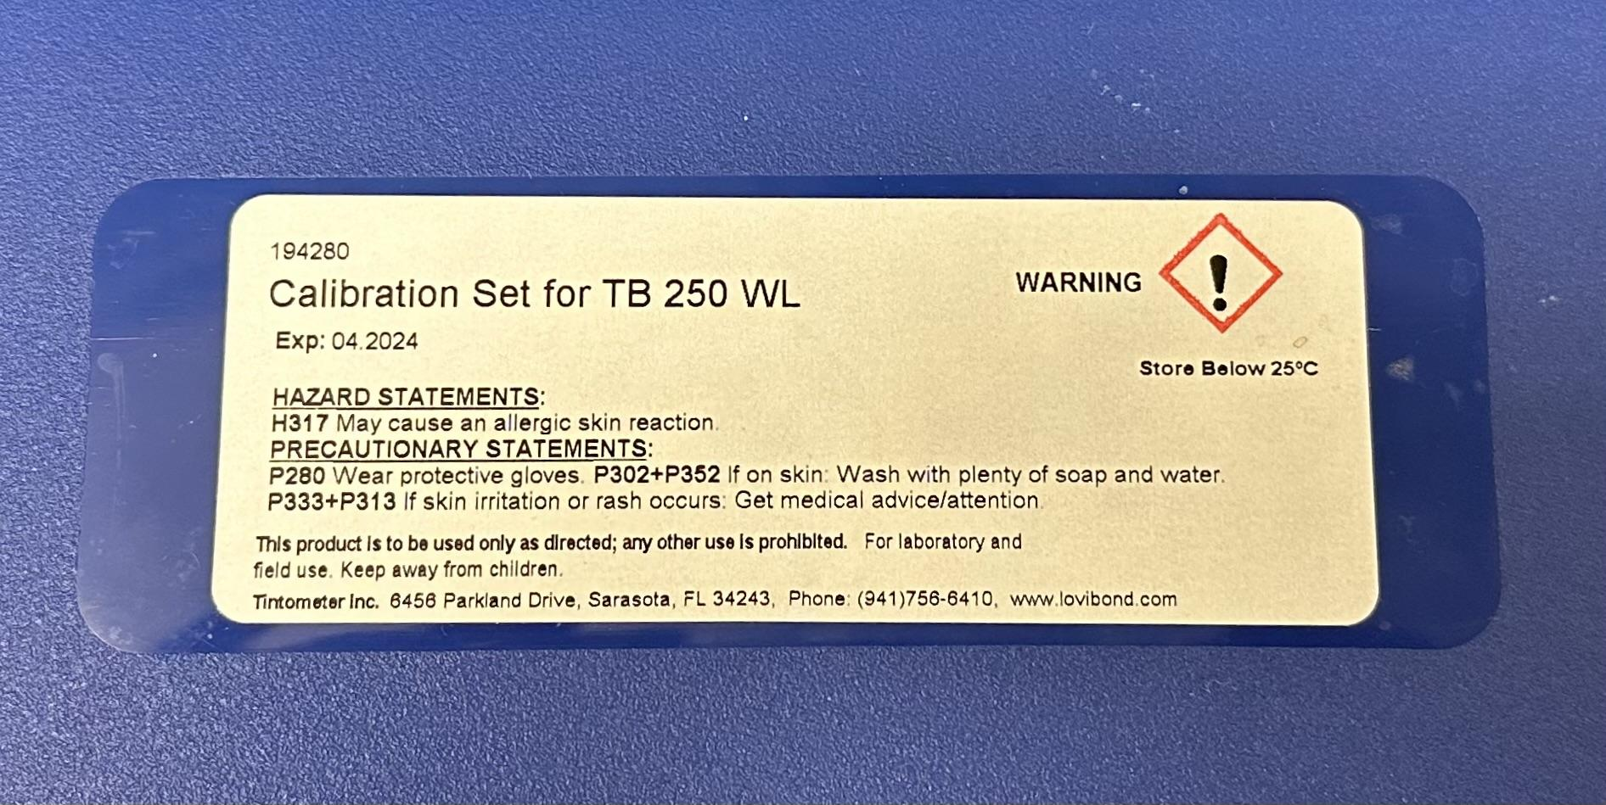

*Figure 17: Calibration Kit*

Important Things to Keep in Mind:

* The turbidimeters should be calibrated every 90 days (3 months)
* Use the long tubes for calibration, not the small ones

*Figure 18: Tubes for Calibration*

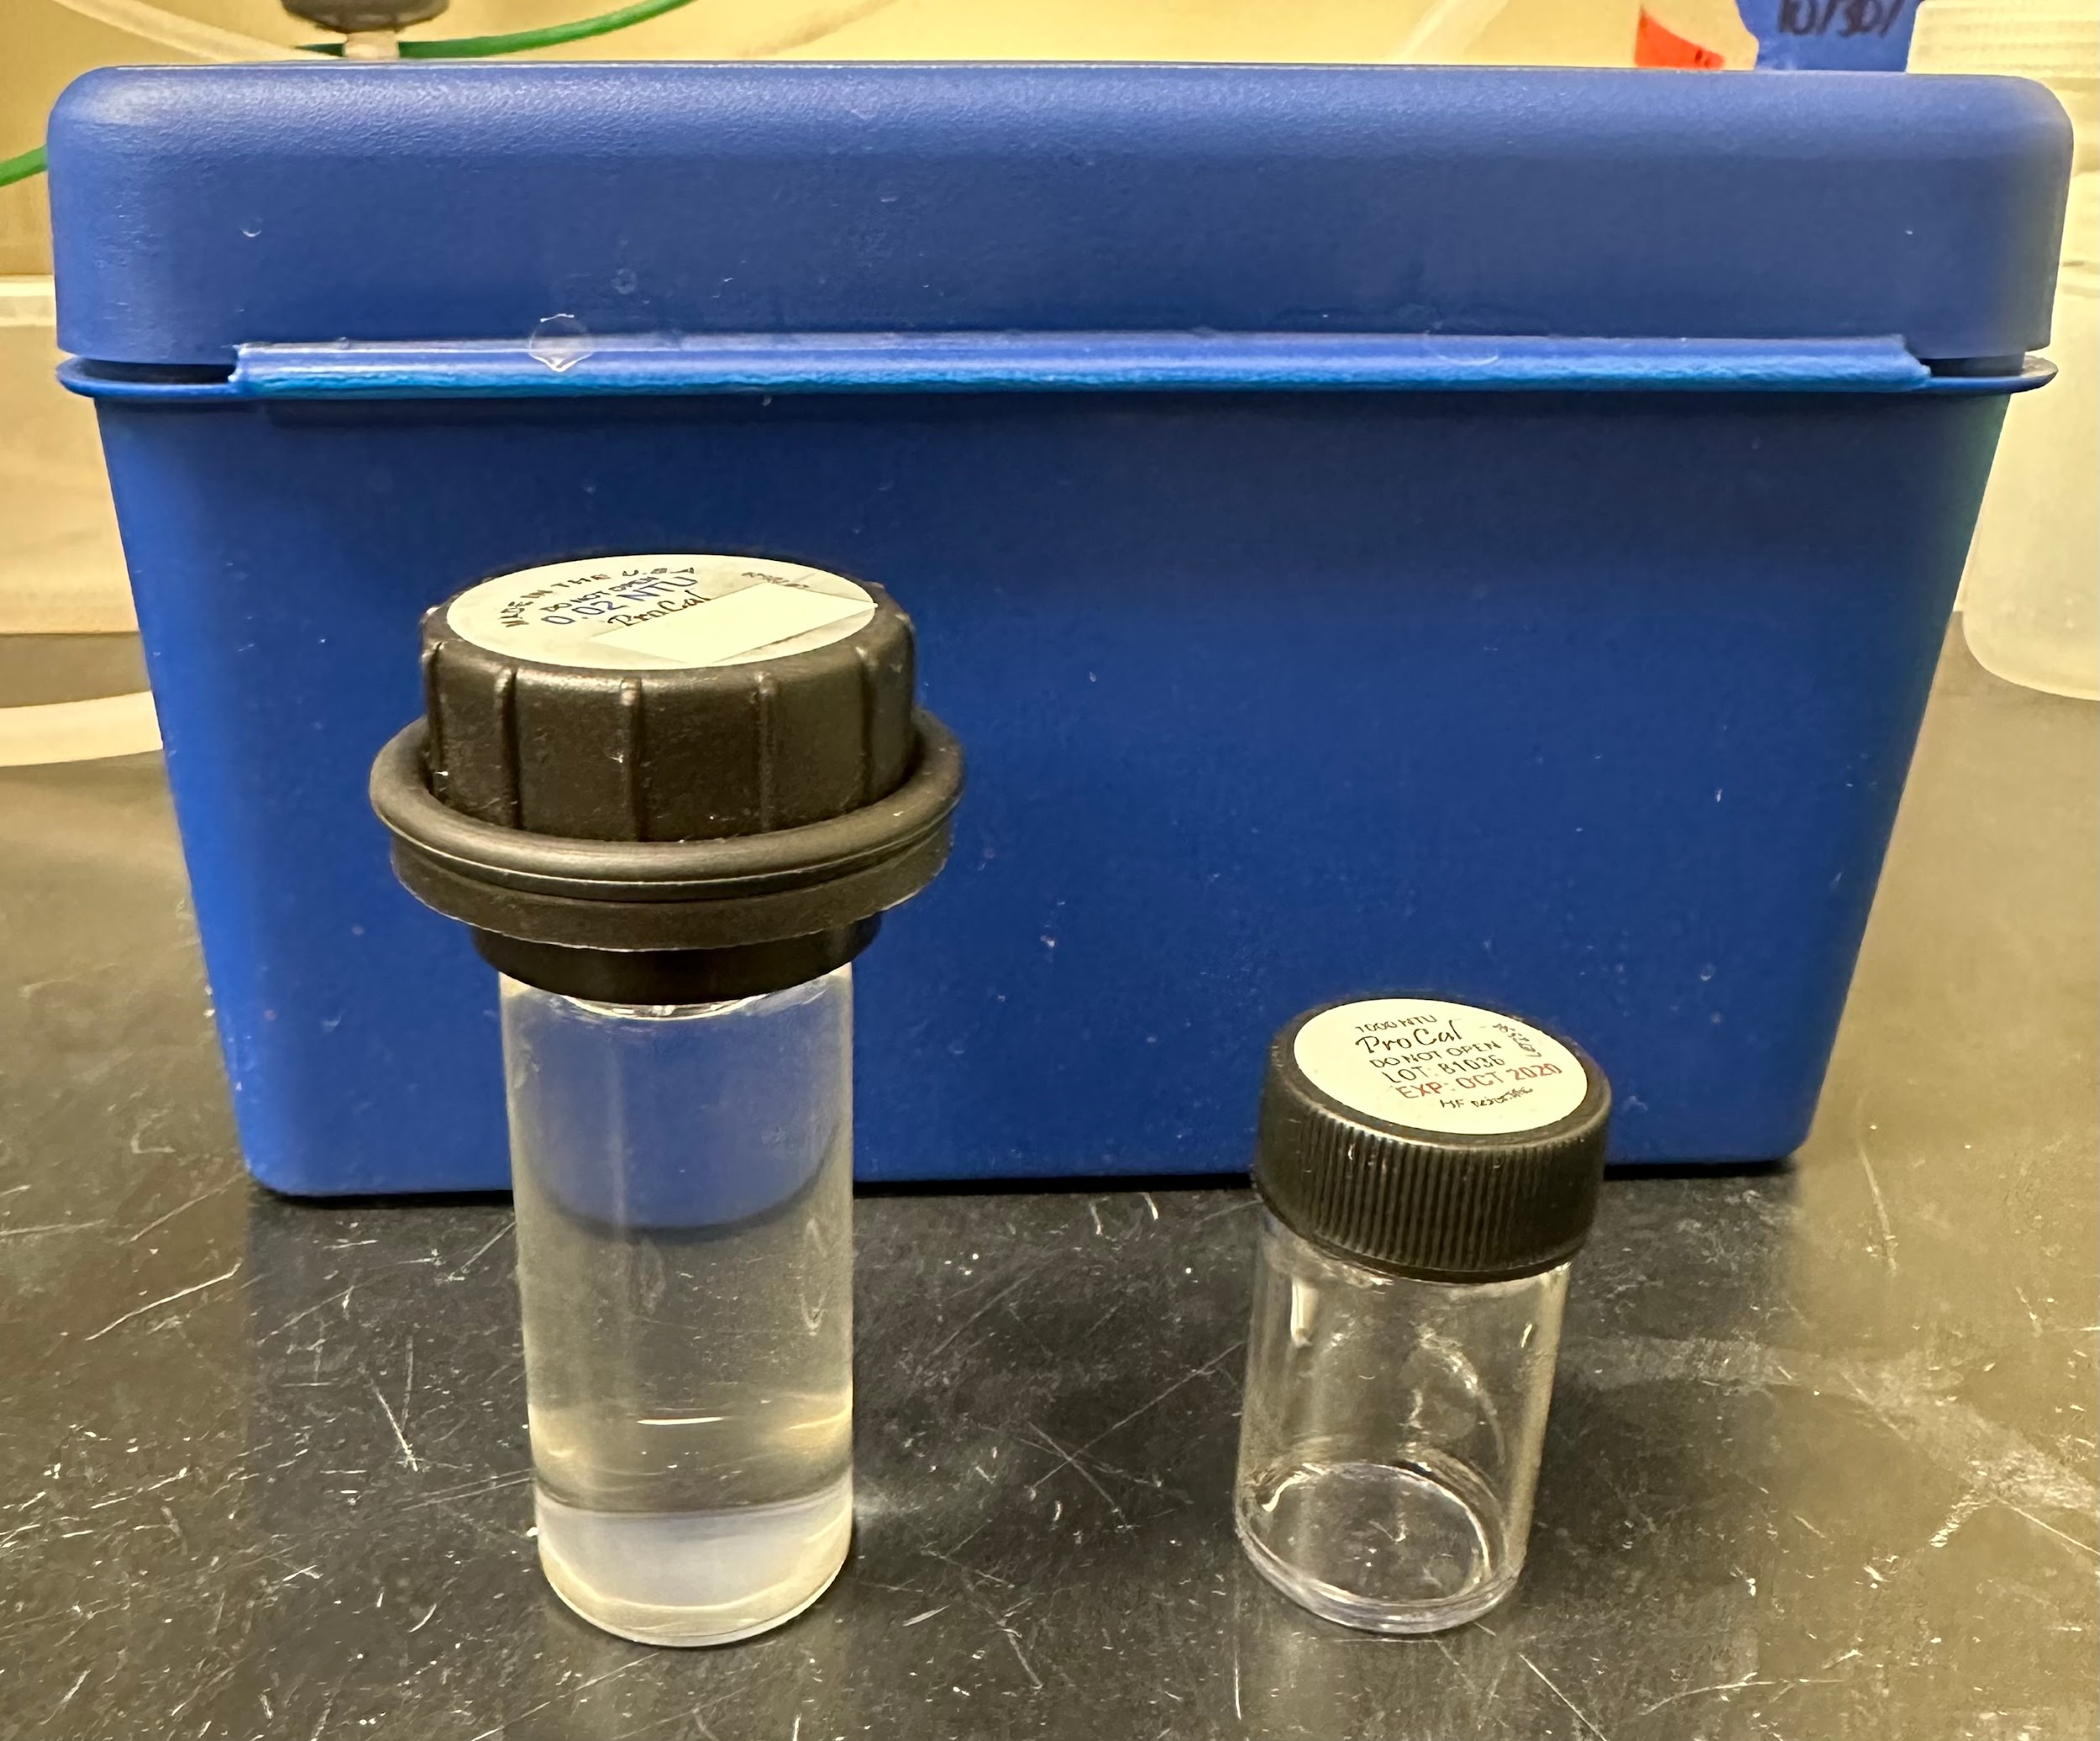

Long tube

Short tube

* To connect to ProCoDA: Set the ID on the turbidimeter itself by clicking the ‘Mode’ button twice and the ‘Enter’ button twice so that you see ‘ADDR’ on the bottom. Then press up and down to the number you want. Make sure the setpoint ID has the same number on ProCoDA.

*Figure 19: The ‘Mode’ button is boxed in red and the ‘Enter’ button is boxed in yellow*

* Make sure the turbidimeter is not measuring current– if it says 4-20, change to 485 under ‘CONFIG’ on the turbidimeter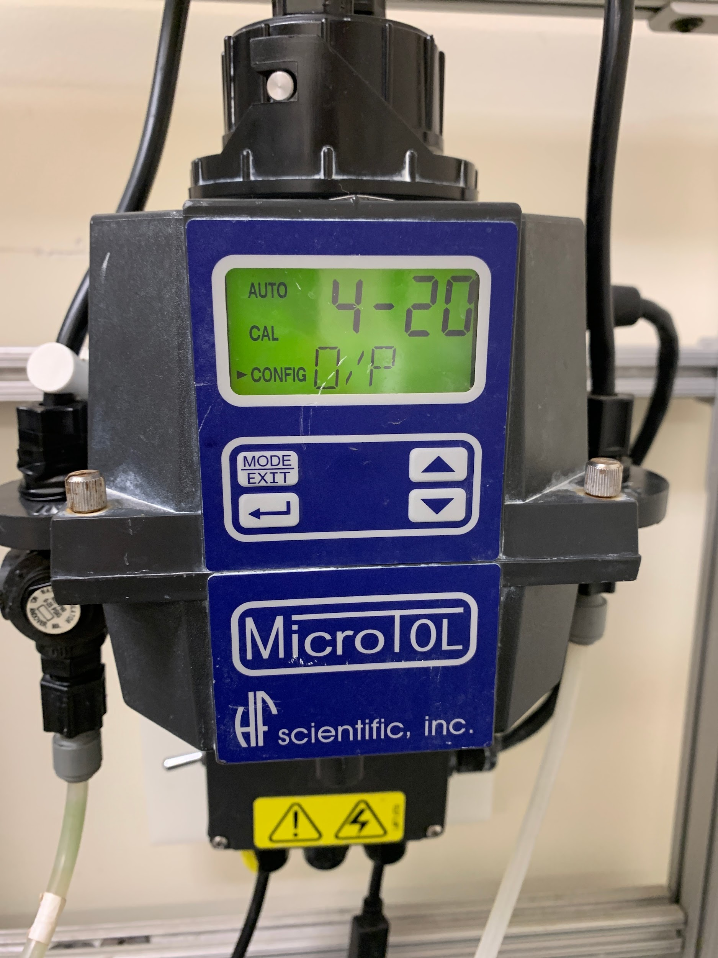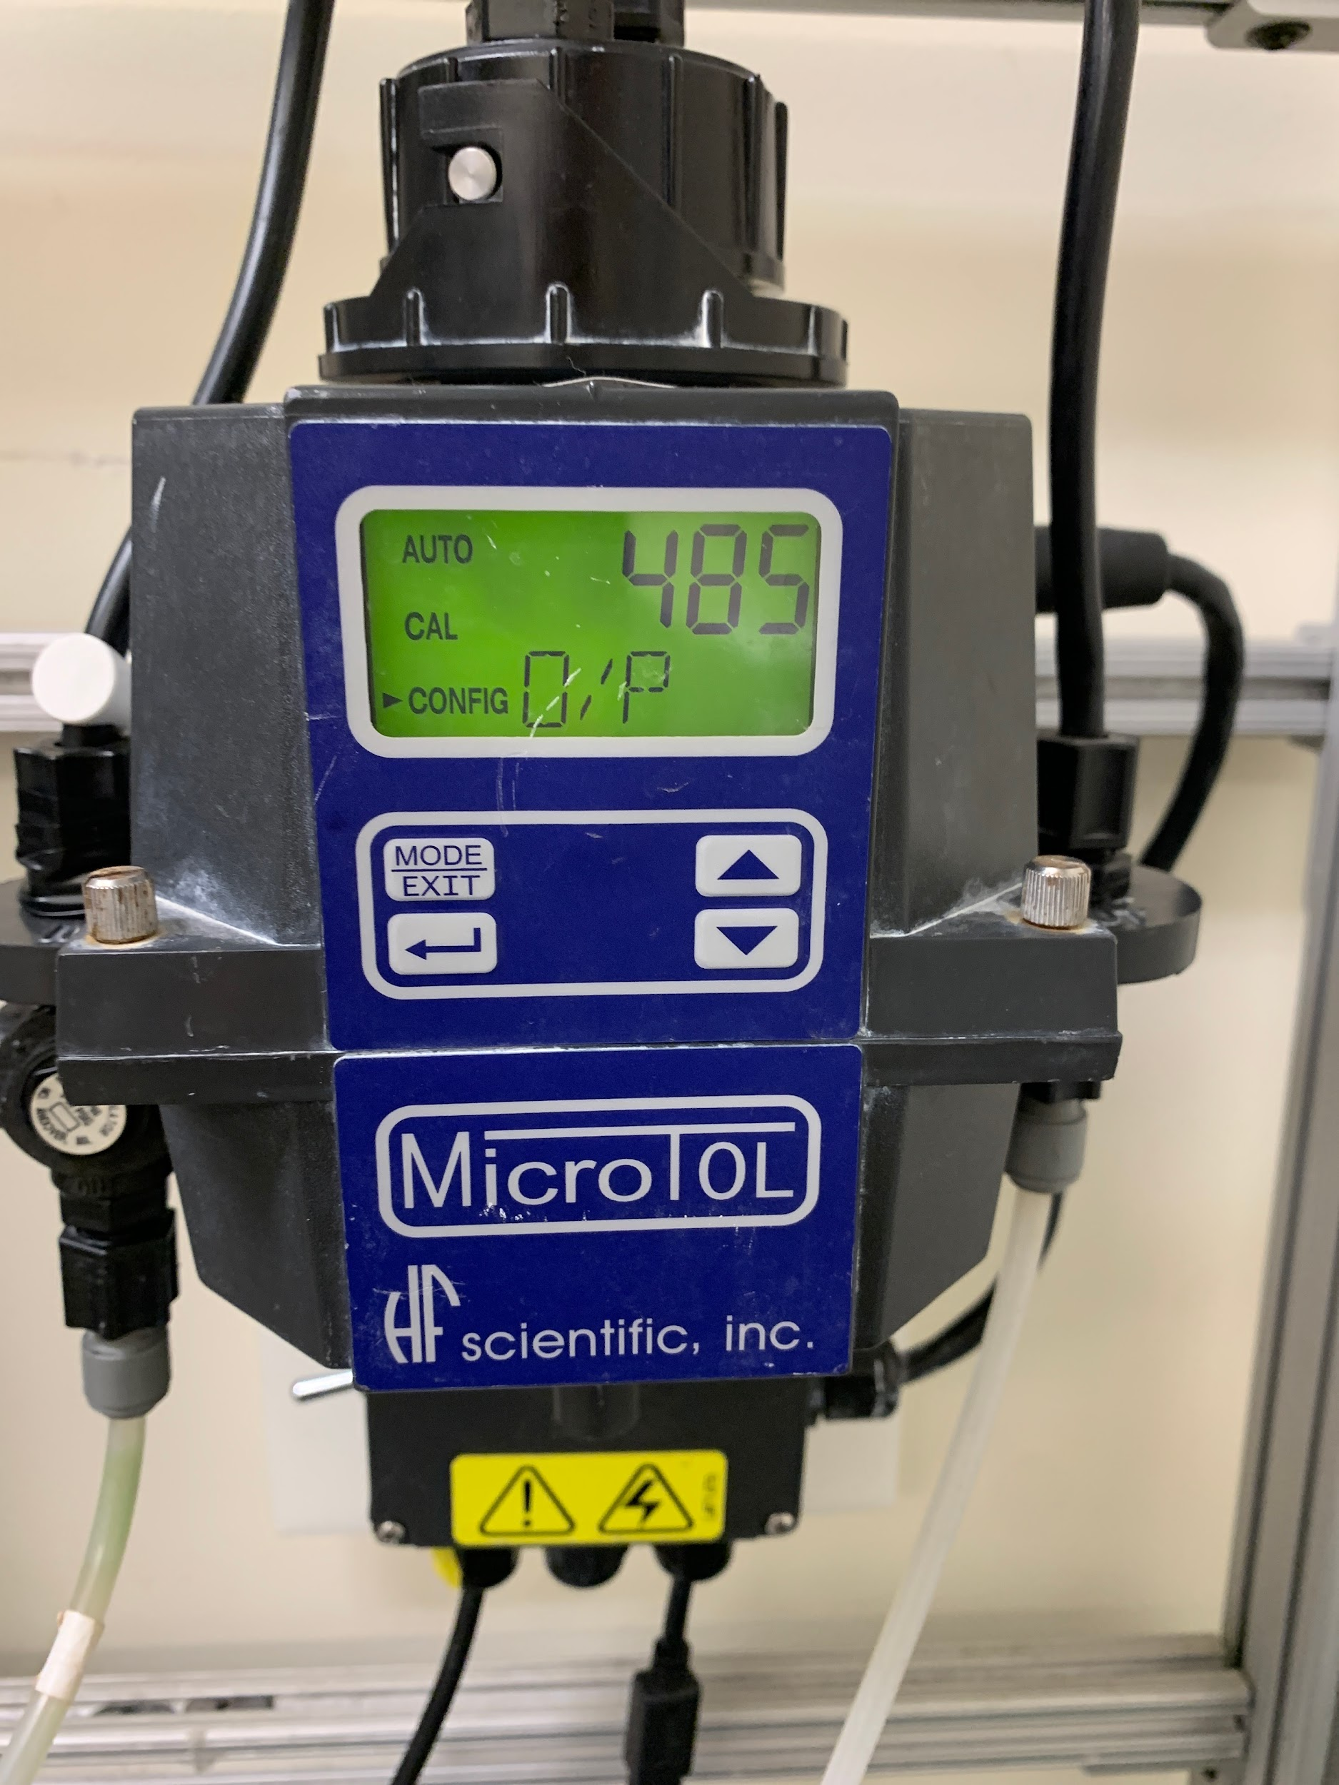

*Figure 20: Incorrect turbidimeter screen Figure 21: Correct turbidimeter screen*

Creating Graphs

1. Select the data you want to analyze by clicking on a variable under ‘data to plot’ in the ‘Graphs’ tab
   1. Can have multiple variables analyzed at once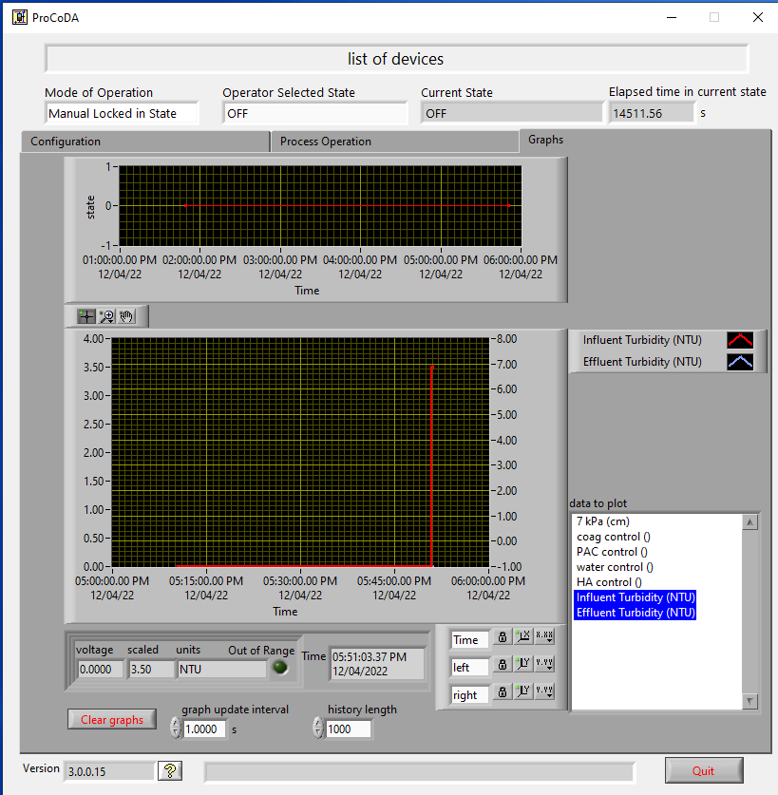

*Figure 22: Plots of Measured Variables Over Time under the ‘Graphs’ tab*

1. Can change axes (left or right) by right-clicking on the arrow next to what you are measuring and selecting right or left if the ranges/scales are different



*Figure 23: Customization of the Plots By Right-Clicking the Red or Blue ‘Up’ Arrows*

Saving data

Data collected from the influent and effluent turbidimeters via ProCoDA can be saved as TSV files on the lab computer.

1. Create a separate folder for all future data files (recommended because ProCoDA will automatically create new files everyday so it is better to keep them separate from the non-data files in the computer)
2. Select the correct directory in the “Datalog directory path” section using the “file” icon. Check that the end of the path is the name of your folder.



*Figure 24: ‘Datalog directory path’ selection box. The button in the lower right should turn green if the path is valid.*

1. Click on the ‘save’ button to store data in the datalog and statelog file of that day.

*Figure 25: The ‘save’ button is in the middle of the three buttons under the ‘Method files’ tab*

*Figure 26: Example datalog file. New ones are created everyday and can be found in the folder the directory has been sent to.*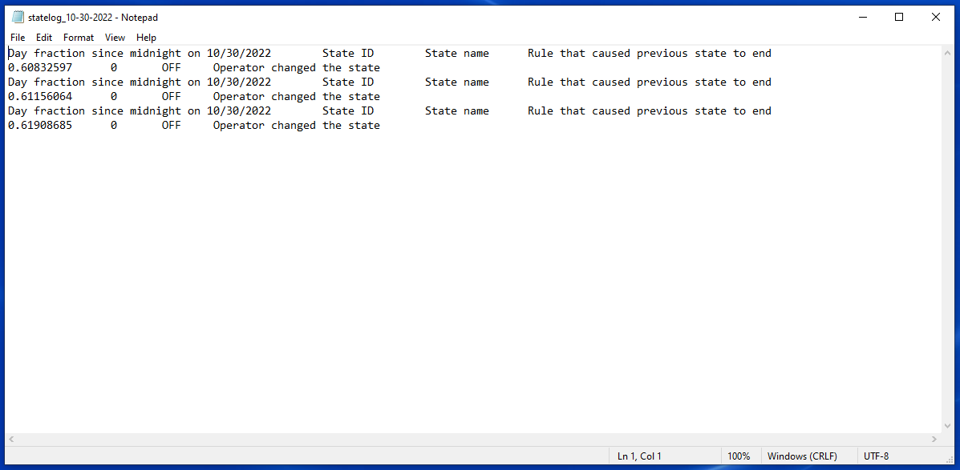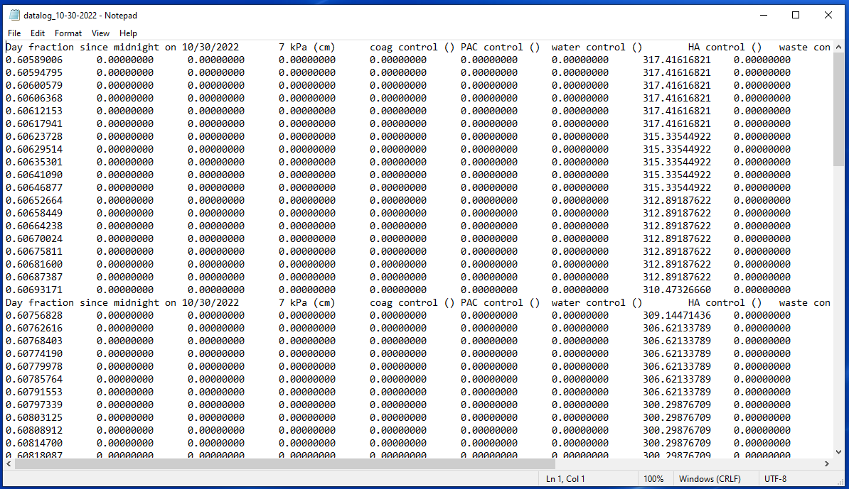

*Figure 27: Example statelog file.*